SUBJECT: Derating Curve for 34044-3
author: larry lim
TECHNICIAN: larry lim
REPORT NO: ENG-11-SEPT-2020-2
date: 09/11/2020

- Part Description:
34044-4-000 Rev G
SW: 0112

- Equipment List:
High current test fixture. 80TK Thermocouple Module, Multimeter, Espec Test Chamber

- Test Setup:

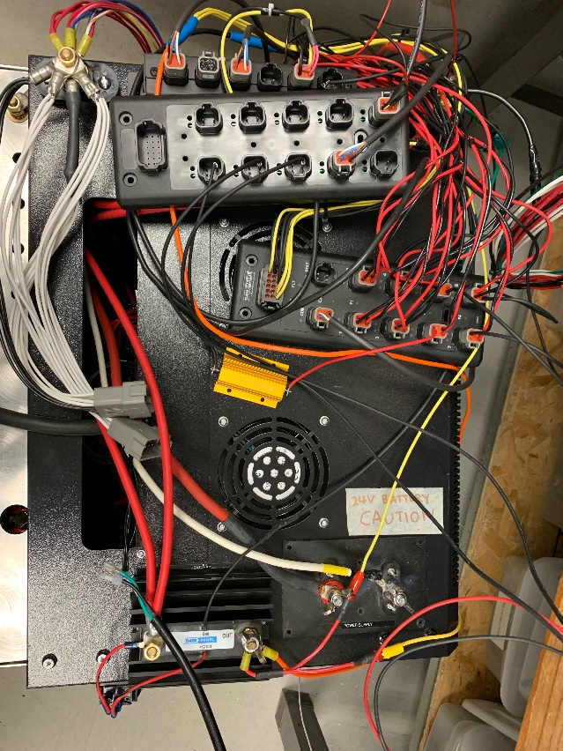 | Unit is first run at ambient. Total temperature increased is subtracted from 80°C to be used as a starting point for derating curve.  Next point on curve would be to start with a minimum load and slowly increase the load until temperature reaches 80°C

- Results:

Ambient: 27.2°C
Load Current: 52.6A
Highest Temperature Recorded: 50.8°C
Total Temperature Increase:23.6 °C

56.4°C starting point for derating curve.

Set temperature: 65°C
Load Current: 45.5A
Highest Temperature Recorded: 78.6°C
Total Temperature Increase: 13.6°C

- Reference Data:

