SUBJECT: Load test 50 amps 34044-5
author: Fred sauer
TECHNICIAN: fred sauer
REPORT NO: ENG-05-nov-2020-1
date: 05/11/2020

- Part Description:
34044-5-000 PCB Rev B and Rev C

- Equipment List:
High current test fixture. 80TK Thermocouple Module, Multimeter, Espec test chamber

- Test Setup:

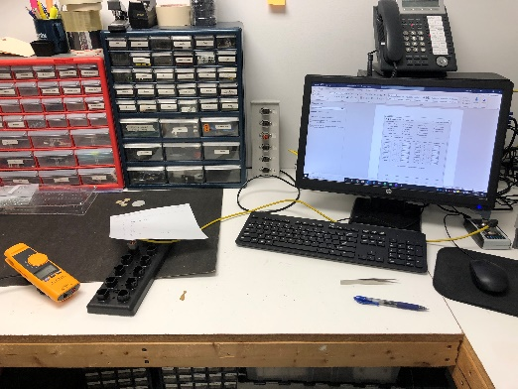 | 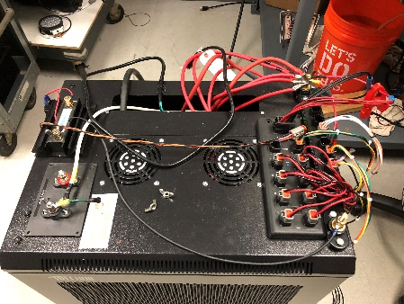
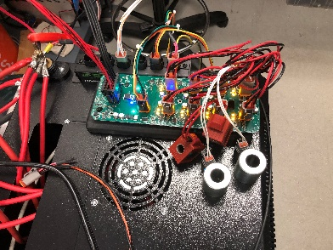 | 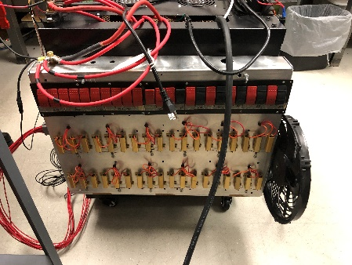

- Results:

Ran a series of output load tests on two 34044-5 PCBs. Both had been tested and calibrated on the PAT factory test.  PC xtremDB tool showing settings and snapshot of data. | 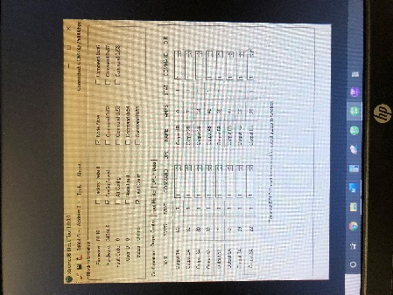
Amp readings for first unit. Rev B PCB. | 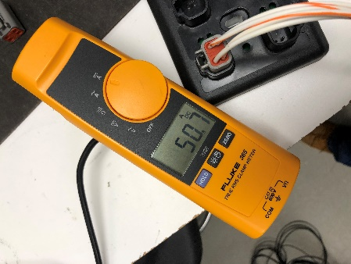
Amp readings for the second unit. Rev C PCB. | 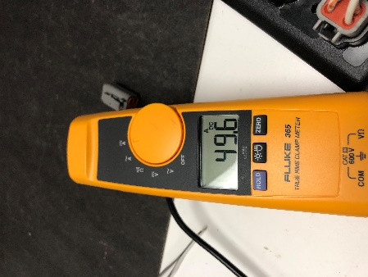
Additional test for the second unit. Added five amps to the load bank. | 