SUBJECT: 34044-5 SHORT CIRCUIT TESTING
author: lARRY lIM
TECHNICIAN:
REPORT NO: ENG19JAN21-1
date:

- Part Description:
- The 34044 family of parts are DPBlock Active Modules with Outputs and Inputs as listed in the table below. The device has a solid state design with digital or PWM outputs, digital or analog inputs. It is designed to meet the requirements of the utility truck market. Input/Output functions and connector pin-outs are defined by the specific part number configuration.

- Equipment List:
- Power Supply, Electronic Load

- Test Setup:

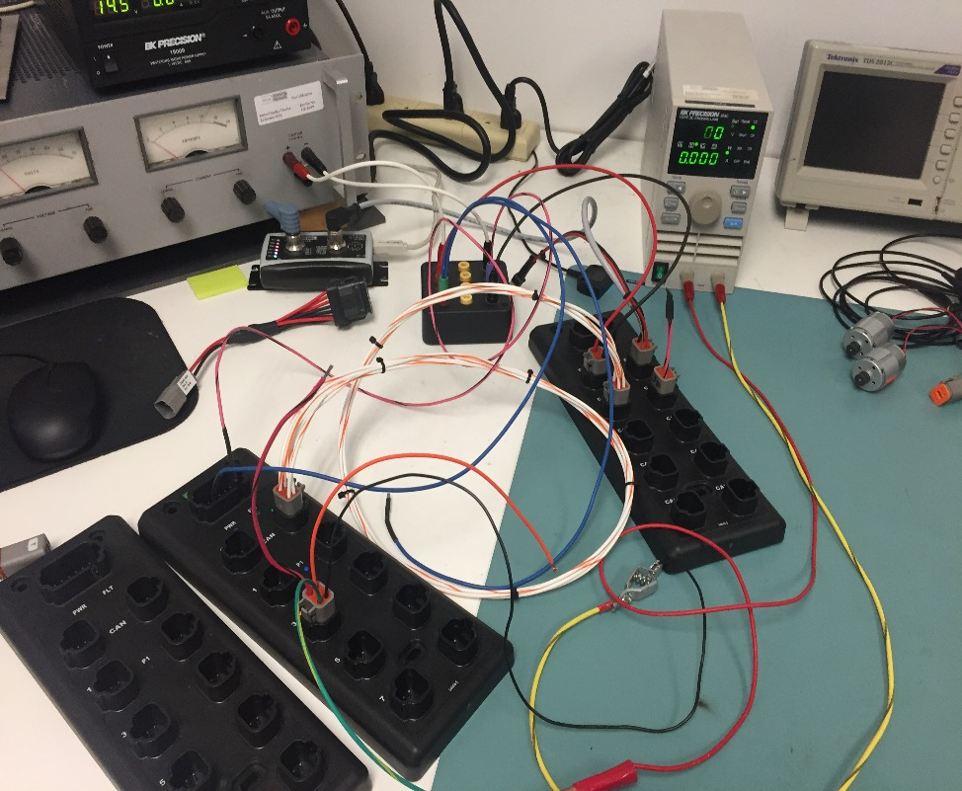

- Results:

Firmware: 010F
Short to ground while ON: Faulted
Short to battery while OFF: Did nothing
Firmware: Refer to 34044-5 FET SLEEP HACK
Short to ground while ON: Faulted
Short to battery while OFF: Did nothing

- Reference Data:

